3.3 I can select and use appropriate tools to upload and publish the website

I downloaded Filezilla and selected my files to view them on there.

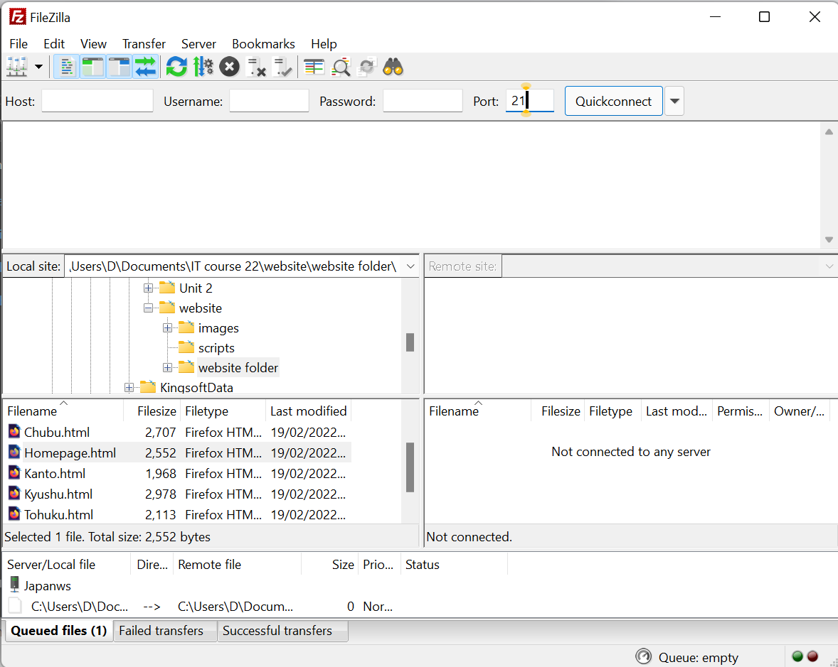

[The Above image shows Filezilla open on my computer and the files in the file window]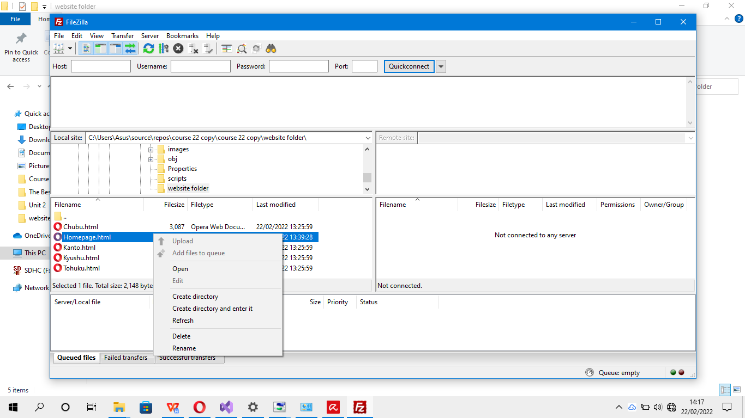

[The above photo shows that you can right-click the web page file (.HTML) and upload it to host]

You can also queue stuff to be uploaded for big websites. companies such as news outlets might use this to queue upcoming stories.

The host, username and password portion of the site is used for the administrator’s use for uploading files to the web pages. The port shows the firewall protections that the admin uses but most use port 21.



